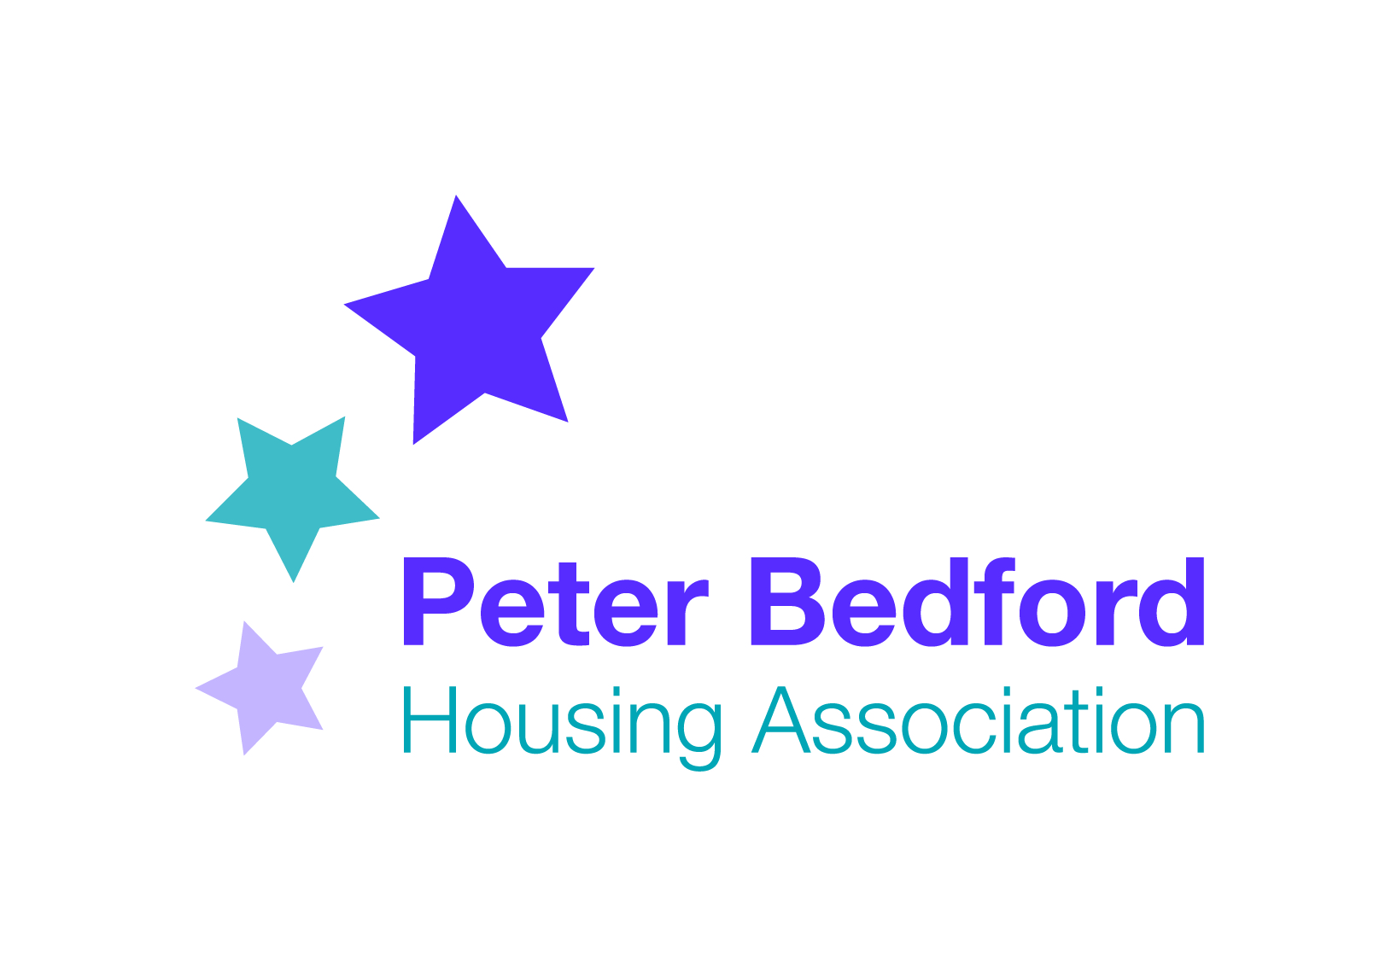
Minutes of PBHA Forum
7th September 2017
@ Kingsland hub

Present: Antony Brown, Patrick Caffrey , Precious Martini Brown, Laura, Paul Stanek, Elaine King, staff: Vernella Dyer, Anjum Ahmed, Vanessa Morris

- Actions from last meeting: Update on fire safety policy- Vanessa confirmed that PBHA will not be requesting that tenants stay put in case of fire- everyone should leave the building unless unsafe to do so. Fire retardant bedding given to all residents of our supported accommodation. Fire safety upgrade programme is almost complete. Tenants can help improve fire safety through not leaving items in communal hallway which can prevent people getting out in case of fire. We will be upgrading communal hallways using fire retardant paint and carpet. Fire brigade offer home fire safety appointments.
Vanessa sought more feedback on proposed shortened tenants survey- 7 questions. All agreed this was a better approach. One request for an additional question on safety, but agreed that comments on this can be included in additional comments section.

- Timebanking: Discussion on proposal to join with an organisation called Spice to develop a timebank – only in Hackney, for 6 months, while we are developing our own timebank. Advantages is that they have access to free events, tickets to leisure facilities across London. Is this a problem if only open to Hackney tenant? Precious had changed her views, and thought it useful to link in with other timebanks so there is more opportunity to spend. Forum agreed to continue with developing own timebank, and to make connections with other timebanks when established.
- Tenant attendance at next board meeting: Vanessa sought volunteers to feedback from the tenants forum to the next board meeting. Patrick and Precious interested.
- Safer neighbours team: invite police to forums. Action: Vanessa to invite SNT to forthcoming forums and Isledon and Clissold.

- Trip: Tenants and participants expressed disappointment that trip didn’t happen. Vanessa emphasised that PBHA approach is to help tenants arrange own events through sharing responsibility rather than to put on for tenants. Patrick noted that PRIDE is led by tenants, with a bit of staff support, but thinks other organisations put on trips for their tenants. Vernella to return money collected. Forum agreed they didn’t want a trip to take place in autumn due to the cold. Tenants wanted a named member of staff to help out with planning the trip.
- Xmas Party: Started having a discussion on how arranging this could be done with tenants leading; carried forward for further discussion next meeting.
- Contractors: carried forward to next meeting
- Window cleaning and gardens: carried forward to next meeting
- Evictions: carried forward to next meeting
- Service charge details: carried forward to October meeting

