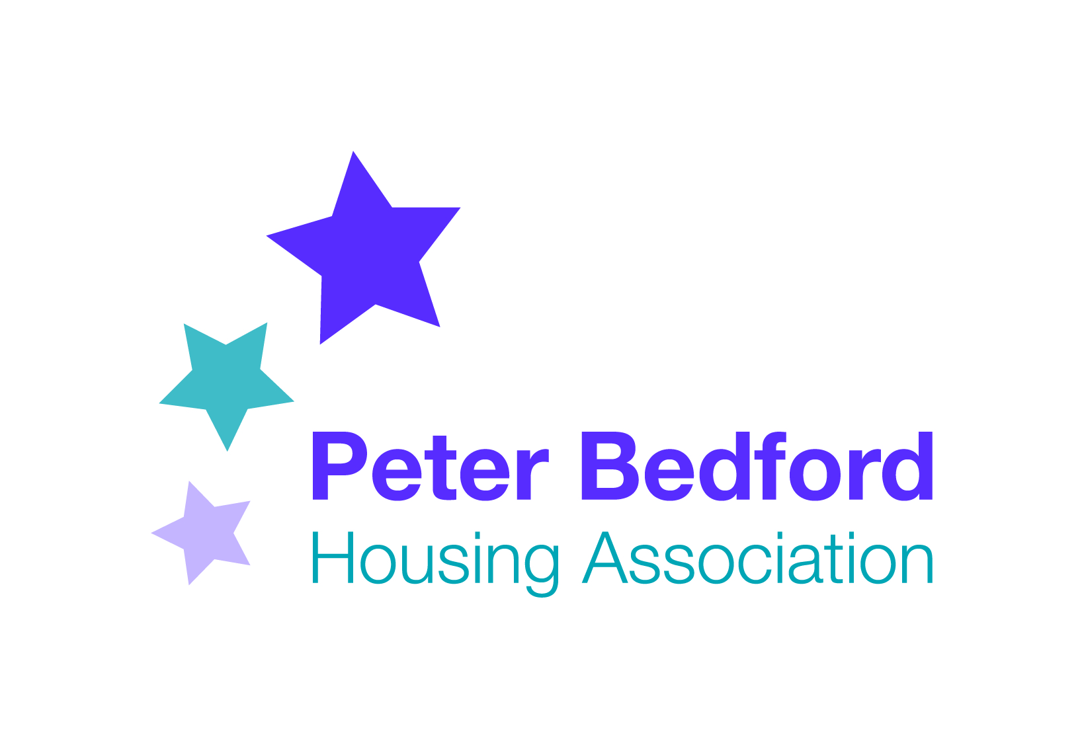
Minutes of PBHA Forum
6th December 2017 1 pm
at Kingsland hub

Present: Four tenants,1 participant
Vanessa Morris, Anjum Ahmed,Vernella Dyer(staff)

Chair: PMB
Minutes: RGS

Update on minutes of previous meeting: http://peterbedford.org.uk/news/peter-bedford-housing-association-forum/

Minutes of previous meeting were agreed.

- Asset Management
VM updated forum that PBHA has been completing a 30 year plan on how to invest in keeping our properties in good condition. Some works will be completed in the next few months- with tenants notified. A large programme of improvements is planned for next year. PBHA will notify tenants and seek ideas before starting. Works will mostly consist of internal and communal decorations, kitchens and bathrooms. A tenant asked if those not affected could also be notified- PBHA agreed to notify.

- Universal Credit. 5 focus groups being held over December and January to inform tenants about major changes to benefits system and how PBHA can help make the change smoother for tenants. Details were sent to all PBHA properties and are in Rising Star: http://peterbedford.org.uk/RisingStar
- Tenants Xmas party- volunteers needed to decorate Isledon Canteen on Saturday 9th. Discussed who’s doing what for party. Tenants to call reception to confirm coming. Xmas meal is at Isledon Canteen on Christmas Day- to pay in advance by 17th December. Transport can be provided from Clissold for tenants unable to make their own way.
- Items in hallway/ fire safety. Discussed tenants leaving items in communal hallways; a tenant said this had not been an issue before and PBHA should still allow it. VM confirmed this isn’t possible, as can cause blockage of means of escape in case of fire.
- Website: a tenant said they were finding it difficult to find items on website. We looked at the website to locate the item- forum minutes. Website is under review at the moment, and forum minutes and Rising Star have already been made earlier to find. There is a search button to enable tenants to locate information too.
- Responsive Repairs contractors- some tenants have started a petition. No one at forum had full details.VM said she’s aware of some issues ,which the property team is working through, and asked if anyone having difficulties contact the property team to make a complaint directly.
- 2018 Forum Planning. Discussed dates and format. A tenant reported that some tenants asked if forum could not be held at Kingsland. Staff explained importance of holding at each hub- accessibility- and at Kingsland is opportunity to see what employability, adult learning and services by other organisations are available at the hub. Discussed whether to have meetings bi- monthly, and whether to change format- e.g. themes agreed in advance, or workshop format. Lani,new Peer Support and Participation Officer ,is post soon, and will start seeking ideas on how we can keep the forum fresh and relevant to as many tenants as possible.
Dates for the 2018 forum were agreed and will be published on website.

DATE OF NEXT MEETING: Tuesday 23rd January at 1pm at Isledon Hub.

