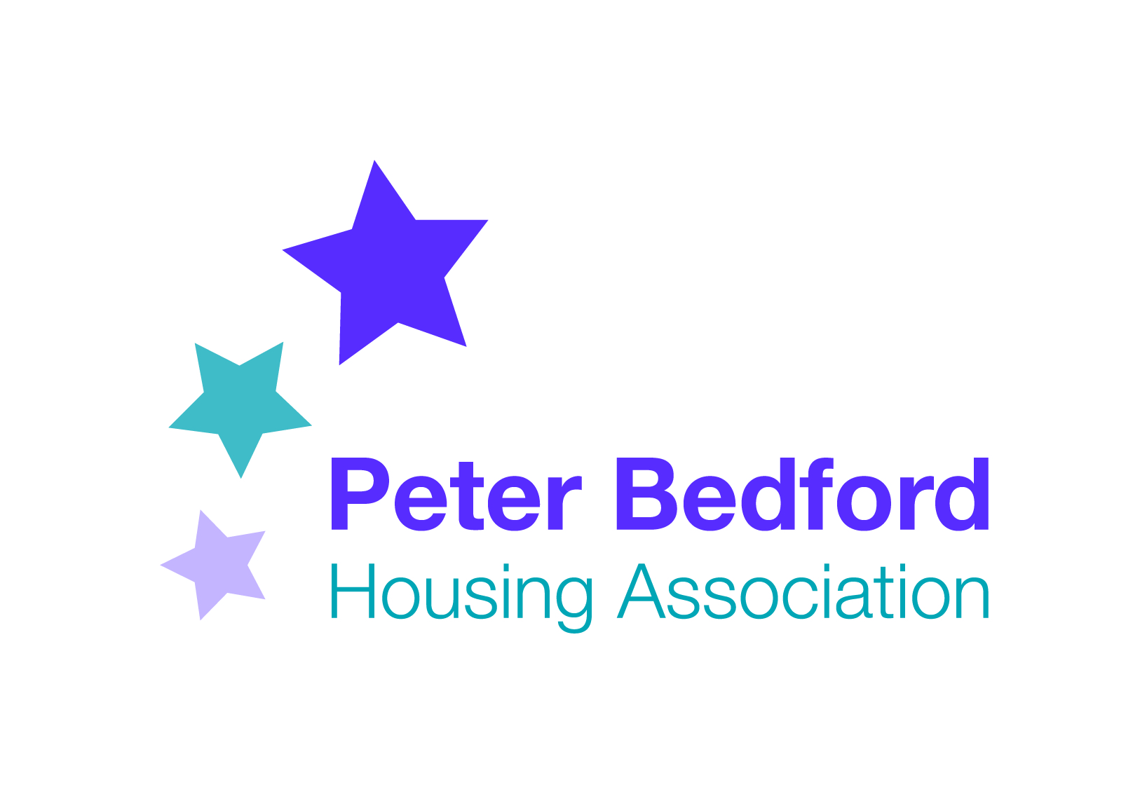
Minutes of PBHA Forum
Thursday 6th October 2016

Present: 5 Tenants, 2 participants, Clare Norton (CEO), Vanessa Morris (Head of Services), Sophie Brownson (Outpost), Mandy Mansfield (Participation Officer), Kevin Smith (Matrix)
Apologies: PC, KO’L, MM
Chair: NJ

Agenda
1 Minutes and Matters Arising
2 Matrix Assessment
3 Changes to Support
4 Repairs and Responsive Repairs tender
5 New leaflets/Charters
6 Budget – TV at Isledon/Hi-fi at Clissold
7 Gas Safety Policy
8 Bonfire at Clissold
9 Danny Taylor
10 Workshops at Outpost
11 AOB

1 Minutes and Matters Arising
- Introductions - Those present introduced themselves to the Forum
- Flood Update at Kingsland - Clare updated the forum that ISHA (Kingsland Hub landlord) are still investigating why the flood happened, and are the drains and plumbing up to scratch. We are hoping to move back into Kingsland Hub the end of the month. Staff are working from a temporary office near Geffrye Street Workshop. PBHA have sought legal advice should any type of flood happen again.
- Phones at Isledon - There is a new Isledon Office number – 0203 815 4057
2 Matrix Assessment
Kevin explained that Matrix is a quality mark for Information, Advice and Guidance. Kevin has been visiting various services within PBHA, to look at how they are managed, how services are run, and how well ideas and change is communicated. He has been speaking to Managers, staff, tenants and participants. Kevin asked if the forum could continue with him as an observer, so he can see how changes are communicated.

3 Changes to Support
There was a comment that letters have been received inviting people to the AGM, but if there are literacy issues, and no support worker, how do tenants deal with that? How do people deal with Housing benefit forms?

Clare replied that PBHA is starting EHM drop-ins at Clissold , where tenants can access workers. EHM workers can also visit people in their homes. Robert, (Income Officer) does drop-ins at Clissold on Fridays and Isledon on Thursdays, and he can help with HB forms. ACTION: A poster with drop-in times to be done for Clissold.

Tenants and staff need to work together to find solutions to issues as they arise. PBHA will be fundraising to plug any gaps in the EHM service.

4 Repairs/ Responsive Repairs tender
Repairs. At the recent AGM, Disability rights UK challenged PBHA tenants to do as many simple repairs as possible themselves. Are tenants interested in attending basic DIY courses? One tenant stated she does her own decorating and tiling. It was suggested we give tips about saving money, e.g. using the washing machine after 7pm saves a lot of electricity, and using gas instead of electric kettle also saves money.
Responsive repairs tender.
Though tenants were invited to take part in the interview process, no tenants attended. PBHA has interviewed potential contractors, looking at how quickly, how expensive, the quality and what added extras they might be offer. All contractors have committed to offering training and apprenticeships for tenants.
PBHA are marking the different contractors and putting it to the Board. The winner will start in February 2017. Tenants will be asked to rate the quality of the repairs carried out, and there will be a Repairs Resident Liaison Officer. The Liaison Officer will be invited to future Forums.

There was a question when the planned maintenance is taking place. A new Assets and Property Manager is starting in the near future, and is a trained surveyor. She will be looking at the results of the stock conditions survey dealing with kitchens, bathrooms, internal decs and flooring.

5 New leaflets/charters
PBH A has produced new, clearer leaflets and charters, that were distributed. These replace the old tenants handbook, and should be easier for new tenants to understand. They are available in all the hubs. Leaflets are:
Understanding and paying your rent
Staying safe at PBHA
Get involved at PBHA
Property Services
Dealing with antisocial behaviour
Living at PBHA
Useful Addresses and phone numbers

There is also a Supported Housing Charter which sets out what tenants and participants can expect from us, and what PBHA expects from tenants and participants.

The information is available on the website, and the next stage is to produce videos explaining the information. The forum asked if anyone is interested in being in a video for the website.

It was asked if there is a punched folder available for people to keep the leaflets in. There was a plan to produce a folder with pockets but PBHA ran out of funds to do this. At the moment they are put into envelopes.

PBHA is now looking at standard letters and rent statements, and asked for volunteers to help make sure they are clear, understandable and in plain English. 2 people (one with literacy issues and one with English as Second language) volunteered to help draw these up.

6 TV at Isledon/CD Player at Clissold
There is £1,300 left in the participation budget. A TV license and installation would cost approx. £400 in total (TV - £200, License £145, Installation £50). This will only leave £900 for all activities until April. The TV would be used for DVD afternoons, occasional film nights and for training. The Forum voted to buy a new TV for Isledon Canteen.

A tenant had asked if Clissold could have a CD player. A Hackney tenant offered to donate her CD player to Clissold canteen. Thank you Mandy K.

7 Gas Safety Policy
PBHA is reviewing its gas safety policy. It is a legal obligation for landlords to check gas safety every 12 months. It was asked if tenants are aware how important this is. Those present agreed it is very important.
It was asked how PBHA should arrange access – letter or telephone? Those present agreed that telephone is the best way to agree appointment times.

There is a proposal that the most vulnerable are contacted every 10 months, as it sometimes takes a few months to arrange access.

The forum was asked about out-of-hours appointments. It was agreed that these are most appropriate for people who are working or have daytime commitments.

Escalation Procedure – If PBHA cannot access the property, we are not allowed to use keys to enter, but need to take the matter to court to get an injunction to enter the property.
It is proposed that if this happens, the tenant will be liable for the court costs.

More informal ways of alerting the tenant was discussed, such as putting caution tape across the door. A DVD about the gas checks was suggested.

8 Bonfire at Clissold

Precious is organising a bonfire party on Saturday 29th October, from 4pm-8pm. It is celebrating the end of the growing season. There will be food and singing around the fire. There will be no fireworks unless people bring their own and are responsible. No bangers please. All welcome.

9 Danny Taylor

A tenant asked for the circumstances of Danny’s death. Not a lot of detail is known, except that Danny sadly passed away in hospital from natural causes recently.

10 Workshops at Outpost

Sophie introduced herself as a worker who started at Outpost 4 months ago. She reported that Outpost has been making a profit recently. As well as the shop there is a community space for exhibitions, and workshops.

On 21st October there is a launch called Enterprising People, funded by the Big Lottery award. It coincides with Outposts 3rd birthday. Sophie asked for people to get involved. It was agreed to take some plants from Clissold garden.

Sophie went through a questionnaire asking for feedback about what types of workshops would interest people to make the journey to Outpost. Comments included that tenants at Clissold do not always hear what exhibitions and workshops are taking place. ACTION: Contact details given to Sophie to send posters etc for the noticeboard. Suggestions included pottery, still life drawing and furniture upcycling. It was pointed out that people might prefer to attend as a group, and Saturday workshops were of particular interest. Mandy agreed to leave the questionnaire at Isledon for people to complete.

10 AOB

- Kevin announced that PBHA has met the standards for Matrix accreditation
- Participation. Mandy M informed the Forum that she has now left her role as Participation Officer, and has started as full time Wellbeing Coach. She thanked everyone for their support over the last two and a half years. There will be no Participation Officer or Forums for a while until the role is advertised.
- Date of Next Forum tbc
- Christmas party needs to be planned

