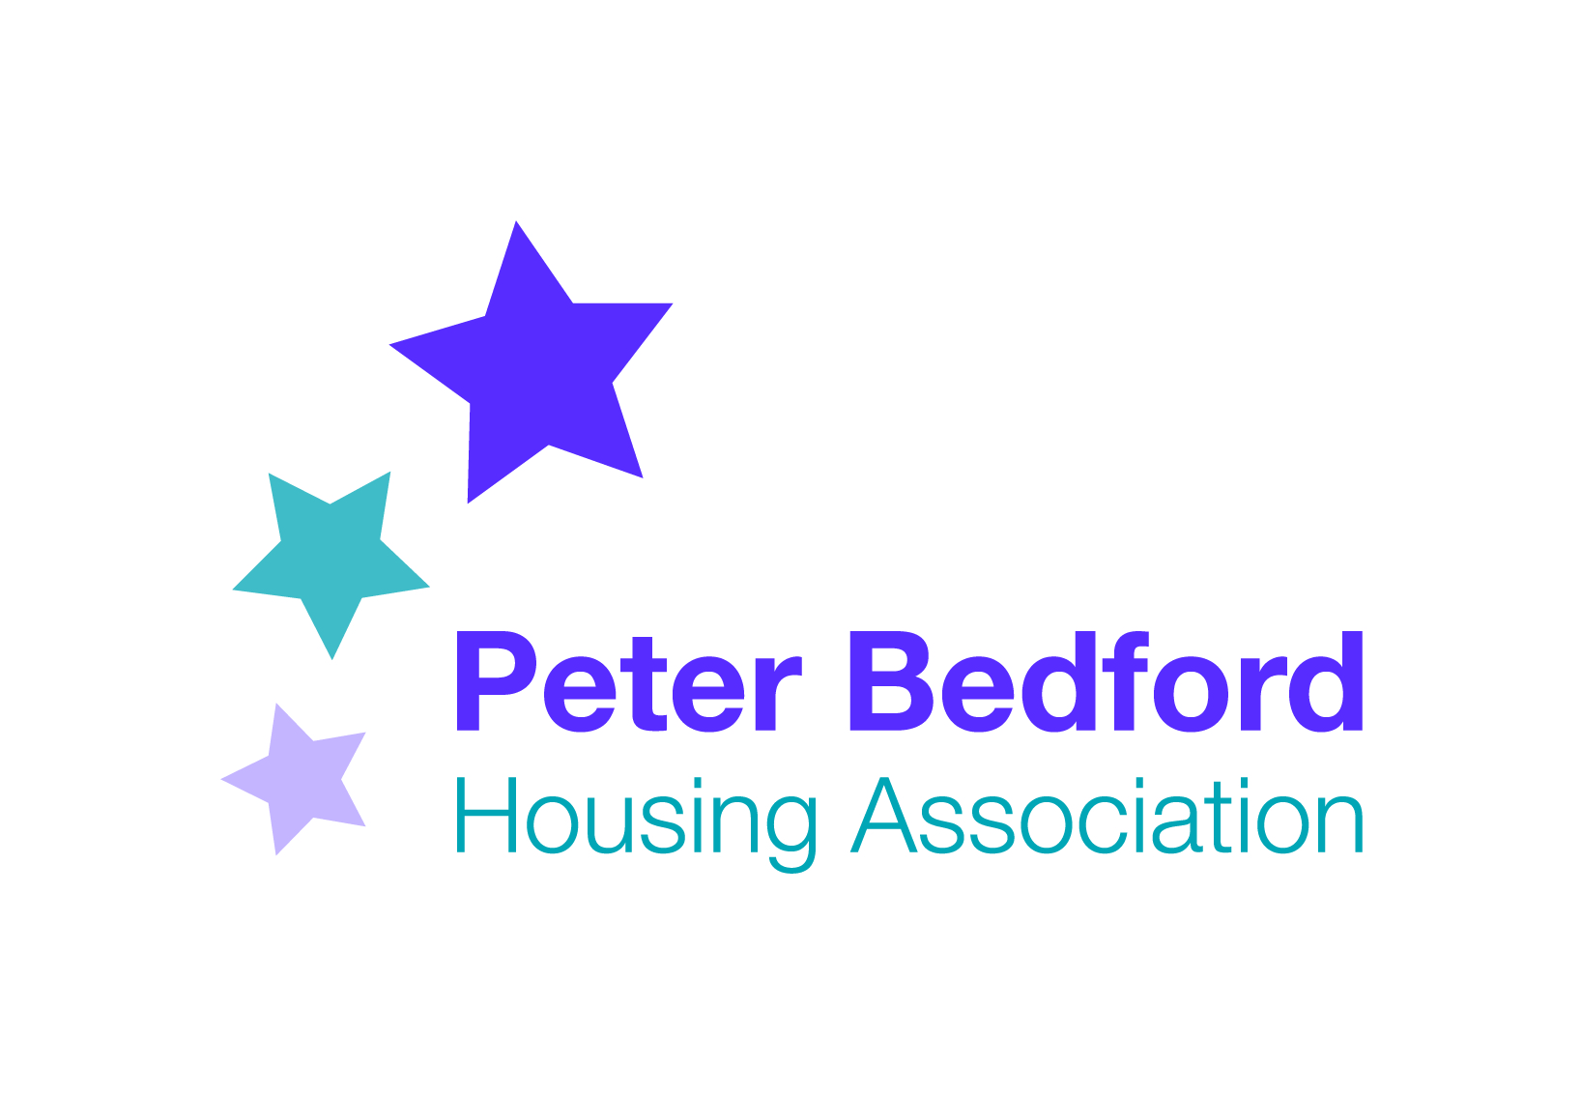
Minutes of PBHA Forum
Tuesday 12th January 2016

Present: 4 Tenants and participants, Vanessa Morris (Head of Services), Michael Havard (Head of Business), Mandy Mansfield (Participation Officer)
Minutes: Mandy Mansfield
1 Minutes and Matters Arising
2 Fundraising Plans
3 Complaints consultation
4 CCTV
5 Update on use of Clissold Canteen
6 New Welcome Coffee mornings
7 Health & Safety consultation
8 Date and place of next meeting
9 AOB

1 Minutes and Matters Arising

- Christmas Day at Isledon. A record 30 people attended Christmas Lunch at Isledon Canteen. Well done and thank you to Patrick, Carol, Precious, Mark and Heni for preparing, cooking, serving and organising other entertainments on the day.
- Larger print version of staff structure. An up-to-date larger print chart was distributed.
- Laptops at Isledon. We do not have money available at the moment to purchase new laptops. ACTION: Mike will look into fundraising options over the next month.
- Tenants Satisfaction Survey. Staff will be analysing the results of the survey and will feed back in due course. Tenant Edmund Davie won the prize draw.

1 Fundraising Plans

Mike Havard, Head of Business, introduced himself to the Forum. Mike spent four years in his previous job working at a national children’s charity as a fundraiser. He is responsible at PBHA for raising money through statuary organisations, trusts and local authority commissioning teams. He will be overseeing income through Outpost, Creative Industries and the café. He has just finalised work on the Big Lottery Reaching Communities bid, and is now in a position to plan different fundraising activities, one being through marketing and social media. ACTION: Mandy to forward dates of Forum, any trips, outings or other activities to Zanna. Mike is also developing a database of ‘friendly’ funders. Mike asked for tenants’ feedback. Suggestions included: A fundraising BBQ at Clissold, jumble sales, and having a fundraising stall on Islington Green. Mike asked for ideas for a wish list. Suggestions included the development of Clissold and Isledon canteens and cooking classes. Also, a TV and DVD player for the Over 50’s Club, as well as money for trips and outings. ACTION: Mandy to attend next Over 50s Club to get tenants quotes for fundraising letters. Mike welcomed further suggestions that can be made informally.

3 Complaints Policy Consultation

PBHA are revising the policy following feedback from tenants. Vanessa introduced a presentation that summarised the main changes.
Stage 1: Acknowledge in 5 working days. Manager investigates and responds in 20 working days. Followed by a complaints satisfaction survey.
Stage 2: Investigation by SMT member, reviewed by another department manager within 15 working days.
Stage 3: External complaint (e.g. Housing ombudsman, Supporting People etc).

Key principals have been set for handling complaints well, including make contact quickly, if we make a mistake admit it, use plain and simple English and have empathy.

Staff will be given training and the forum was asked if anyone would be willing to either take part or have their complaint used as a case study. ACTION: Anyone willing to be involved to contact Mandy or Vanessa.

The forum was asked if there were any other ideas. Comments included clear communication between staff, that general needs tenants are treated the same as supported tenants, and that trust needs to be built.

4 CCTV

A Policy on data protection has been drafted, and we have agreed a quote. There will be a separate consultation with tenants on the block of Isledon in the next few weeks. It will be discussed fully at the next forum.

5 Use of Community Canteens

PBHA is working on a canteen charter and there is an action plan that includes training volunteers in Health and Safety and food hygiene. Fundraising for capital for the canteens is on our ‘wish list’ but we are still in the development stages. ACTION: Vanessa to forward Action points to Mandy and item to be on next Forum Agenda.

6 New Welcome Coffee Mornings

PBHA is introducing new regular coffee mornings at Kingsland Hub. The first one is on Wednesday 20th January, 11am-1pm. The idea is for new tenants to find out what is available to them, and meet staff and tenants in an informal setting. Tenants under 6 months have been invited individually but all tenants are welcome.

7 Health and Safety Consultation

Vanessa distributed a presentation that outlined main changes to the Health and Safety policy, which makes it clear who is responsible for what to meet legal requirements. However this was not discussed at length due to time constraints.

8 Date of Next Meeting.

As the rent consultation is the main agenda item that affects all tenants, both supported and general needs, it was suggested that we have 2 forums in February to accommodate those that work.

Evening: Tuesday 23rd February 6pm-8pm at Isledon Canteen
Day: Thursday 25th February 1pm-3.30pm at Kingsland Hub

AOB

- Committee member Kevin arranged a meeting with Vanessa and Mandy around peer support, mutual aid and SMART Recovery for 10th February at 10am.
- It was requested that move on for short term tenants is on the next Agenda. This will be on the March Agenda.
- PBHA is developing a new Tenant’s Handbook and the draft will be presented to the forum for feedback when it is ready.
- PBHA is working towards being a Mindful Employer, providing support for staff who experience stress, anxiety, depression or other mental health conditions.
- The forum asked that staff continue to pop into Isledon canteen and say hello on Saturdays.
- The Tenant’s Committee requested access to a Dictaphone. ACTION: Mandy to locate PBHA’s dictaphone available

